# Scenario #: Scenario Name

## Scenario Description

* Describe the intent of the test scenario
* Test scenarios (aka test set or test suite) are a set of test scripts that cover a specific functional area, business process, use case, etc…
* For example, a given test scenario might cover an order placed on a web site by an existing customer (another scenario might cover orders placed by new customers) – test scripts within the scenario might cover a single item order, a multiple items order, quantity not on hand exception, etc…

## Version Control

|  |  |  |  |
| --- | --- | --- | --- |
| Version # | Date | Author | Description |
| 0.1 | 01/01/2006 | Author Name | Initial Draft |
| 1.0 | 01/10/2006 | Author Name | Initial Version |

## Test Scripts

The following scripts will cover this scenario:

* 1) Bug 1

## Use Case

* List the Use Case covered by this Test Scenario – limit the test scenario to just one Use Case

## Test Components/Requirements

This test scenario covers the following high-level test requirements (see scripts below for specific requirements covered by each test script):

* Component 1
* Component 2
* Functional Requirements Group 1

## User Groups

* User group/responsibility 1
* User group/responsibility 2

## Script 1: Bug 1

### Script Description

* UAT for Bug 1 of the BRLS System

### Testing Requirements – what am I testing?

This test script covers the following specific testing requirements:

* List all requirements covered by this script – this ensures traceability across all phases of the project

### Setup

* At least 1 Patron Must Be Created
* At least 1 book must exist

### Teardown

* Loan Should Be Returned At The End

### Script Steps - replication

| **Step #** | **Test Action** | **Expected Results** | **Pass/ Fail** |
| --- | --- | --- | --- |
| 1 | Enter L to take out a loan | Loan Use Case UI Shown | P |
| 2 | Swipe Card (Enter 1) | Message About Book To Scan displayed | P |
| 3 | Scan book (Enter 1) | Message prompting either more scanning or to confirm scanning complete | P |
| 4 | Press Enter To Confirm Scanning Complete | A List of all books scanned and prompt to confirm the loans | P |
| 5 | Enter Y To Confirm Loans | A Loan Slip of completed Loans + Message to complete the process | P |
| 6 | Press Enter To Finish Borrowing | Loan Use Case UI Shown | P |
| 7 | Enter T to increment the day | A message shown asking how many days to increment the date of the system by | P |
| 8 | Enter 3 to increment by 3 days | Should display the new date 3 days in the future | P |
| 9 | Enter LL To Show the Overdue loan and related Fine | Will display details about the patron and the loan including the state for both and any fines owed | F |

### Test Execution

|  |  |  |  |  |
| --- | --- | --- | --- | --- |
| Date/Time | Tester | Test ID | Test Phase | Status |
| 16/10/20 12:36 pm | Naomi Thompson | NaomiThompson1 | System Cycle 1 | Failed |

### Test Data

*Step 1*

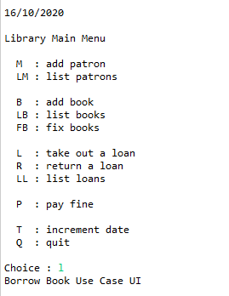

*Step 2*



Step 3



Step 4

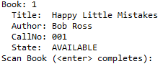

Step 5

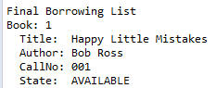



Step 6

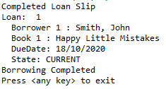

Step 7

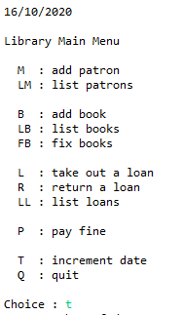

Step 8





Step 9

